**DAILY ONLINE ACTIVITIES SUMMARY**

|  |  |  |  |  |  |  |  |  |
| --- | --- | --- | --- | --- | --- | --- | --- | --- |
| **Date:** | **26-5-2020** | | | | | **Name:** | **Prajna** | |
| **Sem & Sec** | **8th sem ‘B’** | | | | | **USN:** | **4AL16CS067** | |
| **Online Test Summary** | | | | | | | | |
| **Subject** | | **BDA** | | | | | | |
| **Max. Marks** | | **40** | | **Score** | | | **38** | |
| **Certification Course Summary** | | | | | | | | |
| **Course** | **Getting started: Hadoop** | | | | | | | |
| **Certificate Provider** | | | **Great Learning** | | **Duration** | | | **30min** |
| **Coding Challenges** | | | | | | | | |
| **Problem Statement:**1**.** Write a python program to micro and array update. | | | | | | | | |
| **Status: Completed** | | | | | | | | |
| **Uploaded the report in GitHub**  **GitHub link:** | | | | | **Yes**  **https://github.com/alvas-education-foundation/prajna_k** | | | |
| **If yes Repository name** | | | | | **prajna_k** | | | |
| **Uploaded the report in slack** | | | | | **yes** | | | |

Online Test Details: (Attach the snapshot and briefly write the report for the same)

Certification Course Details: (Attach the snapshot and briefly write the report for the same)

Coding Challenges Details: (Attach the snapshot and briefly write the report for the same)

1)online test

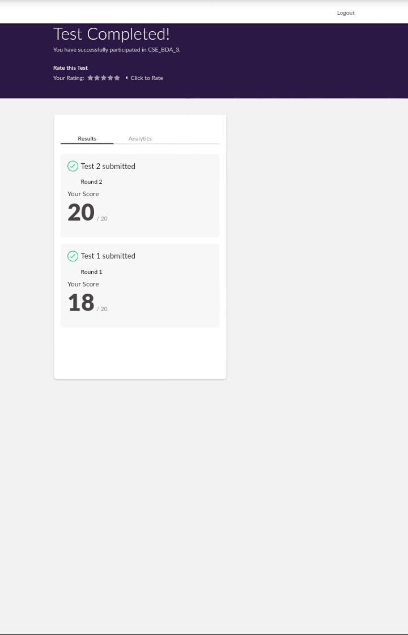

2) certification course

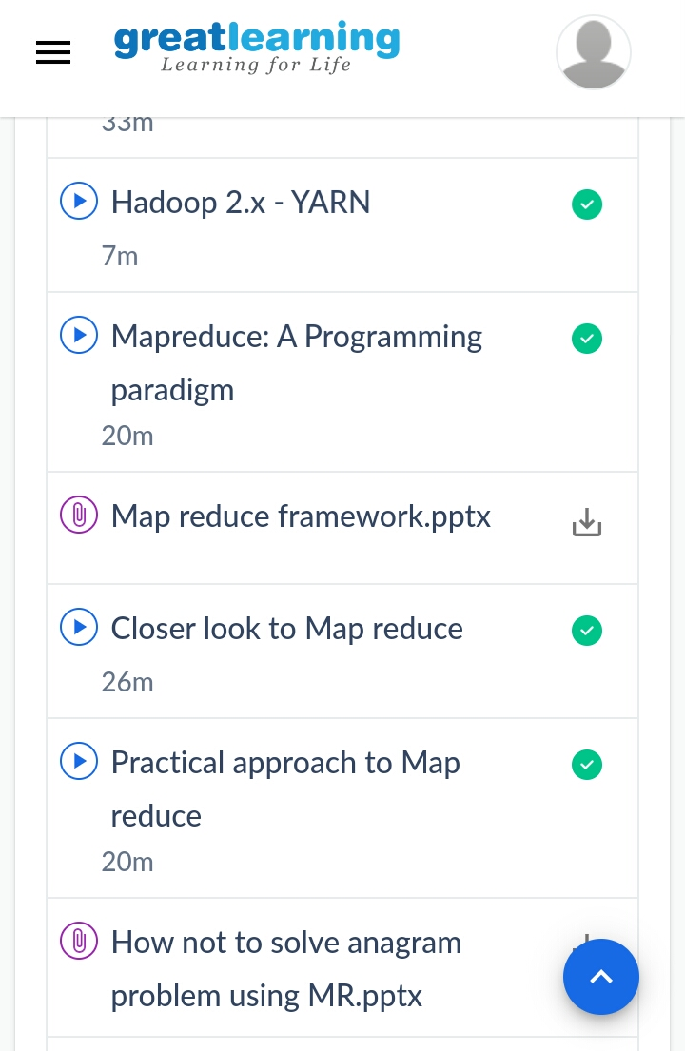

3) coding challenges

**Program 1**

**test=int(input())**

**count=1**

while(test>=1):

print("testcase",count)

lst=[ ]

size=int(input())

k=int(input())

for i in range(0,size):

ele=int(input())

lst.append(ele)

minimum=min(lst)

t=k-minimum

print(t)

print("-----------------------------------")

test=test-1

count=count+1

|  |
| --- |
|  |
|  |  |
|  |  |
|  |  |
|  |  |
|  |  |